# Learning Experience Request (LER) ## 1. Learning Goal What do you want to learn? > Learn what an If–Else Statement is. --- ## 2. Target Audience - School Student --- ## 3. Prior Knowledge: nothing ## 4. Learning Objective What should you be able to do after completing this learning experience? Focus on understanding and application rather than memorisation. Example: > Understand how a computer evaluates a condition and chooses one of two possible actions. --- ## 5. Preferred Representation How would you like the learning experience to be delivered? - Animated Educational Video --- ## 6. Preferred Learning Style Examples: - Story-based --- ## 7. Scenario / Environment Preference Choose the world or setting where the learning experience should take place. - Indian Historical Places --- ## 8. Constraints Specify any important constraints. Examples: - 4 minutes - Beginner friendly - Child friendly - No mathematics - Python examples - Story should remain continuous - Avoid technical jargon initially - Single narrator - Maximum 8 scenes --- ## 9. Output Requirements Specify exactly what should be included in the final learning experience. Examples: - Include misconceptions - Include visual explanations - Include production notes - Include scene descriptions - Include narration - Include character dialogues - Include camera directions - Include animation cues - Include background music suggestions - Include on-screen educational graphics - Include timing for each section - Make the output production-ready for AI video generation --- ## 10. Additional Notes Anything else you want CKLIS to know. Examples: - Keep one continuous story throughout the lesson. - Build intuition before introducing technical terminology. - Reveal programming concepts only after learners naturally discover the underlying pattern. - Correct common misconceptions naturally through the story. - Prefer cinematic storytelling over lecture-style teaching. - Optimize for long-term understanding rather than short-term memorization. - Follow the complete CKLIS learning pipeline internally and return only the final optimised learning experience or final export outcome of pipeline. - Make every design decision based on educational effectiveness if not explicitly specified.

Below is a production-ready educational video package designed according to your Learning Experience Request and aligned with the CKLIS instructional philosophy of Scenario → Observation → Pattern → Mental Model → Programming Concept → Code → Practice → Reflection, emphasizing conceptual understanding before syntax.
Reference Manual

00 - Project Charter

02- Learning Science

🎬 Production-Ready Educational Video

Title
The Secret Gate of Fatehpur Sikri: How Computers Make Decisions (If–Else Statement)

Video Metadata
Item | Value
Duration | ~4 Minutes
Audience | School Students (Beginner)
Representation | Animated Educational Video
Learning Style | Story-based
Setting | Indian Historical Place – Fatehpur Sikri
Difficulty | Beginner
Scenes | 8
Narrator | Single Narrator
Theme | Adventure + Discovery

Primary Learning Objective
By the end of the lesson, learners should understand that:
A computer makes decisions by first checking whether a condition is true or false. Based on that result, it chooses one of two possible actions.

Common Beginner Misconception Addressed
❌ "A computer chooses randomly."
Correction:
Computers never guess. They always follow the result of checking a condition.

Scene 1 — The Mysterious Fort

Duration
30 seconds

Scene Description
Morning at Fatehpur Sikri.
A young explorer named Aarav walks toward the magnificent Buland Darwaza.
Ancient birds fly overhead.
Soft Indian flute music.

Narration
Long ago, emperors built magnificent forts filled with hidden passages and clever designs. Today, Aarav has come to explore one of them. But little does he know that this fort hides a secret that every computer also uses.

Visuals
- Pan across Buland Darwaza
- Aarav walking
- Ancient walls
- Warm sunrise

Camera
Slow cinematic drone shot.

Animation
Dust particles.
Birds.
Moving flags.

On-screen Text
Can one door decide everything?

Scene 2 — Two Doors

Duration
35 seconds

Scene Description
Inside the fort...
A hallway splits into two giant doors.
One says:
OPEN
The other says:
LOCKED
A stone guardian points toward a glowing inscription.

Narration
Aarav notices something unusual. The fort never opens both doors. Only one opens. But how does it decide?

Visual
Two enormous doors.
A glowing stone tablet.

On-screen Graphic
Door A
Door B
Question mark appears.

Camera
Zoom toward tablet.

Scene 3 — Observe Carefully

Duration
35 seconds

The tablet says:
"Show the Royal Seal."
Aarav places the seal.
The OPEN door unlocks.
Later...
He removes the seal.
Now the LOCKED door remains closed.

Narration
Interesting! The doors don't choose randomly. They first check one thing. "Is the royal seal present?" Only after checking do they decide what to do.

Educational Graphic
Royal Seal?
↓
YES
↓
Door Opens
Then
Royal Seal?
↓
NO
↓
Door Stays Closed

Animation
Golden light.
Door gears move.

Scene 4 — Discover the Pattern

Duration
40 seconds

Narration
Let's think like detectives. Every time the seal is present, the same thing happens. Every time it isn't, something different happens. The fort always follows one simple rule.

Visual
Split-screen.
Attempt 1
Seal → Open
Attempt 2
No Seal → Closed
Attempt 3
Seal → Open

On-screen Pattern
Check
↓
Result
↓
Action
Repeated three times.

Camera
Top-down timeline animation.

Scene 5 — The Mental Model

Duration
40 seconds

Narration
Imagine the fort as a careful guard. Before acting, the guard asks one question.
"Is the royal seal here?"
If the answer is Yes...
Open the door.
If the answer is No...
Keep it locked.
Computers think in exactly the same way.

Visual
Animated guard.
Speech bubble.
Seal Present?
YES
NO
Arrow animation.

On-screen Graphic
Question
↓
True?
↓
Choose Action

Background Music
Curious but calm.

Scene 6 — Finally... Programming

Duration
45 seconds

Narration
Programmers give this kind of decision a special name.
It is called an If–Else Statement.
"If" means...
Check whether something is true.
"Else" means...
Do something different if it isn't true.

Visual
Fort transforms into a simple computer illustration.

On-screen Code
PythonRunhas_seal=Trueifhas_seal:
print("Open Door")
else:
print("Keep Door Locked")

Highlight Animation
Glow over:
if
else

Narration
Notice something important.
The computer does not guess.
It simply checks the condition first.

Scene 7 — Practice

Duration
35 seconds

Narration
Your turn.
Imagine you're standing at the fort.

Visual Question
Torch Lit?
YES
NO
Pause.
5 seconds.

Narration
If the torch is lit...
Which door should open?
Think before the answer appears.

Answer Animation
IF Torch Lit
↓
Open Secret Tunnel
ELSE
Stay Outside

Educational Purpose
Active prediction.

Scene 8 — Reflection & Transfer

Duration
40 seconds

Narration
Today we learned something surprising.
The ancient fort wasn't really making magical decisions.
It was simply checking a condition before choosing an action.
Computers work exactly the same way.
Whether it's unlocking your phone...
Opening an app...
Or deciding whether a game character can enter a secret cave...
Everything begins with one simple question.
Is the condition true?
If yes...
Do one thing.
Otherwise...
Do something else.
That's an If–Else Statement.

Final Visual
The fort slowly transforms into a computer circuit.
Then into everyday examples:
- Phone Face Unlock
- Traffic Signal
- Video Game Gate

Final On-screen Summary
Condition
↓
True or False
↓
Choose One Action

Background Music Guide
Scene | Style
1 | Gentle Indian flute
2 | Mystery
3 | Curious
4 | Discovery
5 | Warm & thoughtful
6 | Bright educational
7 | Playful
8 | Inspirational orchestral

Animation Notes
- Warm sandstone palette inspired by Fatehpur Sikri.
- Smooth transitions using glowing sandstone engravings.
- Maintain continuous character movement (Aarav remains the same protagonist throughout).
- Use animated arrows for every decision flow.
- Keep code visually secondary until the concept is established.
- Avoid clutter; emphasize one idea per scene.

Camera Directions
- Slow cinematic establishing shots for historical grandeur.
- Medium shots during discovery.
- Close-ups on the decision tablet and door mechanisms.
- Overhead diagrams for pattern recognition.
- Gentle zooms during key conceptual reveals.
- Smooth morph transition from fort mechanics to computer logic.

On-Screen Educational Graphics
- Decision Flow
- Check
↓
True?
- Pattern
- Question
↓
Answer
↓
Action
- Programming Connection
- IF
↓
True Action
ELSE
↓
False Action
- Final Mental Model
- Condition
↓
True / False
↓
One of Two Actions

Production Notes (AI Video Generation)
- Visual Style: Stylized 3D animation with child-friendly realism.
- Aspect Ratio: 16:9.
- Narration: Single warm storyteller voice with slight dramatic emphasis.
- Transitions: Sand particles and glowing historical engravings.
- Text Style: Large, readable fonts with simple keywords.
- Pacing: Pause 3–5 seconds before revealing answers in prediction moments.
- Historical Treatment: Respectful portrayal of Indian heritage without fictionalizing historical facts beyond the educational narrative.
- 01 - Constitution
- Educational Fidelity: The story maintains one continuous scenario, one dominant mental model, introduces code only after the mechanism is understood, and ends with prediction, application, and reflection to support durable learning.
- 07 – Episode Generation Engine

- 06 – Pattern Mapping Engine

- 08 – Production Engine

Visualize for above

Here is a visual map of the lesson:
Mermaid
IF–ELSE IN ONE LINE
Condition?
├── True → Action A
└── False → Action B

# ROLE You are a Senior Learning Experience Designer, Educational Story Architect, AI Film Director, and AI Production Planner. Your job is NOT to generate AI image prompts or AI video prompts. Your ONLY responsibility is converting the Learning Experience Request (LER) into a complete production blueprint that preserves every educational decision while making the content ready for scene-by-scene AI video generation. IMPORTANT: DO NOT MODIFY THE LER. Do NOT change • Learning Goal • Target Audience • Learning Objective • Preferred Learning Style • Scenario • Constraints • Story Flow • Educational Sequence Only expand them. -------------------------------------------------- # OUTPUT FORMAT ## SECTION 1 Learning Summary - Learning Goal - Learning Objective - Core Concept - Target Audience - Story Theme - Emotional Journey - Teaching Strategy -------------------------------------------------- ## SECTION 2 Story Overview Write the entire story in one continuous narrative. DO NOT divide into scenes yet. The story must naturally teach the learning objective. -------------------------------------------------- ## SECTION 3 Scene Breakdown Divide the story into AI-friendly scenes. Each scene must last only 6–10 seconds. For every scene provide: Scene Number Scene Title Scene Purpose Story Progress Learning Purpose Emotion Beginning State Ending State Expected Duration DO NOT generate prompts. -------------------------------------------------- ## SECTION 4 Character Bible For every character include Name Age Gender Appearance Face Hair Eyes Clothing Footwear Accessories Expressions Body Language Personality Speaking Style Consistency Rules -------------------------------------------------- ## SECTION 5 Environment Bible For every location include Architecture Time Weather Lighting Mood Background Elements Ground Texture Sky Important Details Consistency Rules -------------------------------------------------- ## SECTION 6 Prop Bible List every recurring object. Describe Appearance Material Color Size Usage Consistency Rules -------------------------------------------------- ## SECTION 7 Visual Style Guide Animation Style Rendering Style Color Palette Lighting Style Camera Style Composition Style Mood Educational Graphics Style Subtitle Style Music Style Sound Design Style -------------------------------------------------- ## SECTION 8 Global Production Rules Rules every future scene must follow. Include Character consistency Lighting consistency Environment consistency Costume consistency Color consistency Camera limitations Animation limitations SnapGenAI optimization rules -------------------------------------------------- Return ONLY the Production Blueprint. DO NOT generate scene prompts. DO NOT generate image prompts. DO NOT generate video prompts.

SECTION 1 — Learning Summary

Learning Goal
Learn what an If–Else Statement is.

Learning Objective
Understand how a computer evaluates a condition and chooses one of two different actions based on whether the condition is true or false.

Core Concept
Every computer decision follows the same sequence:
Check → Decide → Act
An If–Else statement simply represents this decision-making process.

Target Audience
- School Students
- Absolute Beginners
- No programming knowledge

Story Theme
The Secret Gate of Fatehpur Sikri
An ancient royal gate opens only for visitors who satisfy a specific rule, allowing learners to observe how decisions are made before introducing programming.

Emotional Journey
Curiosity → Mystery → Discovery → Understanding → Confidence

Teaching Strategy
- Story-first learning
- Observation before explanation
- Pattern discovery before terminology
- Mental model before programming syntax
- Visual reinforcement through repeated examples
- Reflection through everyday situations

SECTION 2 — Story Overview
A young visitor arrives at the magnificent Fatehpur Sikri and notices a mysterious royal gate guarded by an experienced palace guard. Every visitor who approaches the gate is treated differently. Some are allowed inside, while others are politely stopped.
The child carefully watches several visitors approach the gate. Before opening it, the guard always asks one simple question. Whenever the answer satisfies the rule, the heavy gate opens. Whenever the answer does not satisfy the rule, the gate remains closed.
The child becomes curious and begins predicting what will happen before each visitor reaches the gate. After several observations, the child realizes the guard is not making random choices. Every action follows the same invisible rule.
The narrator explains that computers behave exactly the same way. A computer first checks a condition, then decides which action to perform. This is the idea behind an If–Else statement.
The lesson concludes by connecting this ancient gate's decision-making process to familiar everyday examples, helping learners recognize that computers never guess—they simply follow rules.

SECTION 3 — Scene Breakdown
Scene | Title | Purpose | Story Progress | Learning Purpose | Emotion | Beginning State | Ending State | Duration
1 | Arrival at Fatehpur Sikri | Introduce setting | Child enters historical site | Build curiosity | Wonder | Outside palace | Notices giant gate | 8 sec
2 | The Royal Guard | Introduce decision maker | Guard stands before gate | Introduce decision authority | Curiosity | Closed gate | Guard watches visitors | 8 sec
3 | First Visitor | Observe successful outcome | Visitor answers question | Observe "True" path | Interest | Visitor waiting | Gate opens | 8 sec
4 | Second Visitor | Observe alternate outcome | Another visitor arrives | Observe "False" path | Surprise | New visitor | Gate stays closed | 8 sec
5 | Discovering the Pattern | Find repeated behavior | Child notices repetition | Pattern recognition | Excitement | Confusion | Rule identified | 8 sec
6 | Connecting to Computers | Build mental model | Narrator compares guard to computer | Explain decision process | Understanding | Historical example | Computer analogy | 8 sec
7 | Introducing If–Else | Reveal programming idea | Educational graphics appear | Introduce terminology | Confidence | Mental model | If–Else concept | 8 sec
8 | Everyday Decisions | Reinforce concept | Real-life examples shown | Transfer learning | Satisfaction | Programming idea | Practical understanding | 8 sec

SECTION 4 — Character Bible

Character 1 — Curious Child

Name
Aarav

Age
10 years

Gender
Male

Appearance
Healthy Indian school child

Face
Round face with expressive features

Hair
Short black hair

Eyes
Dark brown

Clothing
Light blue T-shirt
Khaki shorts

Footwear
White sneakers

Accessories
Small backpack

Expressions
Curious
Surprised
Happy
Thoughtful
Confident

Body Language
Looks around frequently
Points at interesting objects
Leans forward while observing
Smiles after understanding

Personality
Curious
Observant
Patient
Logical

Speaking Style
Simple
Natural
Child-friendly

Consistency Rules
- Same hairstyle
- Same clothes
- Same backpack
- Same height
- No costume changes

Character 2 — Royal Guard

Name
Palace Guard

Age
45 years

Gender
Male

Appearance
Traditional Mughal-era palace guard

Face
Bearded with calm expression

Hair
Hidden beneath royal turban

Eyes
Dark brown

Clothing
Royal guard uniform
Long traditional robe
Decorative waist belt

Footwear
Traditional leather shoes

Accessories
Turban
Decorative spear
Royal emblem

Expressions
Calm
Serious
Respectful
Friendly

Body Language
Straight posture
Controlled movements
Points toward gate
Opens gate with authority

Personality
Disciplined
Fair
Patient

Speaking Style
Slow
Clear
Authoritative

Consistency Rules
- Never smiles excessively
- Never leaves gate
- Always carries spear
- Always stands near entrance

Character 3 — Visitors

Appearance
Different families and travelers

Purpose
Demonstrate repeated decision examples

Consistency Rules
- Clothing varies
- No recurring dialogue
- Short appearances only

SECTION 5 — Environment Bible

Location 1 — Fatehpur Sikri Main Entrance

Architecture
Authentic Mughal red sandstone gateway
Large carved arch
Decorative pillars
Massive wooden doors

Time
Late morning

Weather
Clear

Lighting
Warm natural sunlight

Mood
Historical
Majestic
Inviting

Background Elements
Courtyard
Stone pathways
Palace walls
Trees
Birds

Ground Texture
Smooth sandstone

Sky
Bright blue

Important Details
Royal flags
Ancient carvings
Large entrance gate
Traditional architecture

Consistency Rules
- Same sunlight direction
- Same architectural style
- Same gate proportions
- Stable background

Location 2 — Gate Interior

Architecture
Stone corridor

Lighting
Softer indirect daylight

Mood
Peaceful

Background Elements
Stone walls
Decorative arches

Consistency Rules
- Matches exterior architecture
- No modern objects

SECTION 6 — Prop Bible

Royal Gate
Appearance
Massive carved wooden double door
Material
Wood with iron reinforcements
Color
Dark brown
Size
Very large
Usage
Represents decision outcome
Consistency Rules
Always opens inward
Same carvings

Royal Spear
Appearance
Traditional ceremonial spear
Material
Wood and metal
Color
Brown and silver
Size
Tall
Usage
Guard accessory
Consistency Rules
Always carried

Palace Emblem
Appearance
Golden royal insignia
Material
Metal
Color
Gold
Usage
Authority symbol
Consistency Rules
Always attached to guard

Educational Graphics
Appearance
Simple floating icons
Usage
Show:
- Condition
- True
- False
- If
- Else
- Arrows
- Decision flow
Consistency Rules
Flat educational style
Minimal animation

SECTION 7 — Visual Style Guide

Animation Style
Stylized 3D educational animation

Rendering Style
High-quality cinematic rendering with simplified educational visuals

Color Palette
Warm sandstone reds
Royal gold
Deep brown
Sky blue
Soft greens
Bright educational accent colors

Lighting Style
Consistent warm daylight
Soft shadows
Natural illumination

Camera Style
Slow cinematic movements
Stable framing
Wide establishing shots
Medium character shots
Occasional close-ups for reactions

Composition Style
Rule of thirds
Clear subject focus
Minimal background clutter
Strong visual hierarchy

Mood
Curious
Warm
Historical
Educational
Optimistic

Educational Graphics Style
Flat vector overlays
Large readable icons
Simple arrows
Minimal text
High contrast

Subtitle Style
Large sans-serif font
White text with dark outline
Bottom-center placement
Maximum two lines per frame

Music Style
Light orchestral
Indian historical influences
Gentle percussion
Curious melodic motifs

Sound Design Style
Ambient birds
Soft wind
Footsteps on stone
Wooden gate creaks
Subtle educational transition sounds

SECTION 8 — Global Production Rules

Character Consistency
- Maintain identical appearance across all scenes.
- Preserve facial features, clothing, accessories, and proportions.
- Expressions should evolve naturally with the story while remaining age-appropriate.

Lighting Consistency
- Use warm late-morning daylight throughout.
- Keep shadow direction constant.
- Avoid abrupt lighting changes.

Environment Consistency
- All architecture must remain historically consistent with Fatehpur Sikri.
- Exclude modern objects, vehicles, signage, or technology.
- Preserve recurring landmarks and background layout.

Costume Consistency
- Aarav wears the same outfit in every scene.
- The Royal Guard remains in full ceremonial attire.
- Visitors may vary in appearance but should fit the historical-tour setting.

Color Consistency
- Maintain a warm palette dominated by red sandstone, gold, and earth tones.
- Educational graphics should use bright, high-contrast colors that remain visually distinct from the environment.

Camera Limitations
- No rapid cuts or shaky camera.
- Prioritize smooth pans, gentle dollies, and static compositions.
- Keep subjects clearly visible for educational clarity.

Animation Limitations
- Use realistic but simplified character movements.
- Avoid exaggerated cartoon physics.
- Ensure all actions clearly communicate the decision-making process.

SnapGenAI Optimization Rules
- Each scene should be self-contained, lasting 6–10 seconds.
- Preserve visual continuity between scenes through consistent characters, costumes, lighting, and environment.
- Introduce only one new educational idea per scene.
- Keep educational overlays minimal and synchronized with narration.
- Ensure transitions are seamless so scenes can be generated independently and assembled into a coherent learning experience.
- Avoid introducing new props, characters, or locations unless defined in this blueprint.
- Maintain a clear visual focus on the educational concept of Condition → Decision → Action throughout the production.

# ROLE You are an AI Cinematographer, AI Prompt Engineer, Character Designer and Image-to-Video Production Expert. You specialize in FREE AI Video tools like SnapGenAI. You receive a Production Blueprint. Your task is to generate ONE scene only. Never generate multiple scenes. ------------------------------------------------------ INPUT You will receive 1. Production Blueprint 2. Scene Number Generate ONLY that scene. ------------------------------------------------------ IMPORTANT Assume NO memory. Every scene must be independently generatable. Every Reference Image Prompt must completely describe Character Clothing Appearance Environment Props Lighting Camera Mood Composition Style Everything. Never say "same character" "same clothes" "same location" Always repeat the entire description. ------------------------------------------------------ OUTPUT FORMAT # Scene Number # Scene Title # Duration (6–10 seconds) ------------------------------------------------------ ## Scene Summary Explain what happens. ------------------------------------------------------ ## Reference Image Prompt Generate one highly detailed image prompt. The image must represent the first frame of the video. Include Character description Face Hair Expression Clothing Pose Accessories Environment Architecture Weather Lighting Mood Props Composition Foreground Background Camera Angle Lens Depth of Field Rendering Style Color Palette Visual Style End with Pixar-quality 3D animation, ultra detailed, cinematic composition, global illumination, volumetric lighting, expressive faces, child-friendly, vibrant Indian colors, professional lighting, 8K. ------------------------------------------------------ ## Reference Image Negative Prompt low quality bad anatomy extra limbs extra fingers cropped logo watermark text duplicate character distorted face wrong costume wrong lighting oversaturated AI artifacts motion blur ------------------------------------------------------ ## SnapGenAI Video Prompt Assume the above image is attached. Describe ONLY Character movement Facial animation Camera movement Environmental movement Emotion Timing Physics One action only. One emotion only. One camera movement only. Maximum 120 words. ------------------------------------------------------ ## SnapGenAI Negative Prompt camera shake face morphing costume changing teleportation extra people distorted movement warping flickering frame glitches text logo watermark low quality ------------------------------------------------------ ## Camera Direction Shot Type Camera Angle Lens Movement Framing ------------------------------------------------------ ## Character Animation Describe body movement precisely. ------------------------------------------------------ ## Environment Animation Describe subtle environmental movement. ------------------------------------------------------ ## Narration Maximum 20 words. ------------------------------------------------------ ## Dialogue If required. Maximum two lines. ------------------------------------------------------ ## Sound Effects ------------------------------------------------------ ## Background Music ------------------------------------------------------ ## Educational Graphics ------------------------------------------------------ ## Transition Suggestion One sentence. ------------------------------------------------------ QUALITY CHECK Verify ✓ Character description is complete ✓ Environment description is complete ✓ Reference image is sufficient for SnapGenAI ✓ Only one action ✓ Only one camera movement ✓ 6–10 second duration Return ONLY this scene.

Which Scene Number from the production blueprint would you like me to generate?
Please reply with a single scene number (for example):
- Scene 1 – Arrival at Fatehpur Sikri
- Scene 2 – The Royal Guard
- Scene 3 – First Visitor
- Scene 4 – Second Visitor
- Scene 5 – Discovering the Pattern
- Scene 6 – Connecting to Computers
- Scene 7 – Introducing If–Else
- Scene 8 – Everyday Decisions
I'll generate only that one scene in the exact production format you specified.

Go one by one

Scene Number
Scene 1

Scene Title
Arrival at Fatehpur Sikri

Duration
8 seconds

Scene Summary
A curious 10-year-old Indian boy named Aarav walks toward the magnificent entrance of Fatehpur Sikri for the first time. As he reaches the wide stone courtyard, he pauses and looks up in amazement at the enormous royal gate, setting up the mystery that drives the learning experience.

Reference Image Prompt
A curious 10-year-old Indian boy named Aarav stands in the foreground of the grand entrance courtyard of Fatehpur Sikri, looking upward with wide-eyed wonder. Aarav has a round expressive face, warm medium-brown skin, short neatly combed black hair, large dark brown eyes, and a bright innocent smile filled with curiosity. He wears a light blue short-sleeved T-shirt, khaki knee-length shorts, clean white sneakers, and a small navy-blue backpack with simple shoulder straps.
He stands naturally with one foot slightly forward, head tilted upward, both hands gently holding the backpack straps while admiring the enormous royal gateway.
The environment is the authentic Mughal architecture of Fatehpur Sikri, featuring a massive red sandstone gateway with intricate carvings, towering arches, carved pillars, heavy wooden doors reinforced with black iron bands, decorative balconies, royal stone steps, sandstone pathways, trimmed green shrubs, and distant palace walls.
The weather is bright and clear during late morning. Warm golden sunlight illuminates the sandstone, creating soft realistic shadows. The sky is vivid blue with a few soft white clouds. Small birds fly high above the gateway while a gentle breeze slightly moves nearby tree leaves and small royal flags.
Foreground: textured sandstone pathway leading toward Aarav.
Midground: Aarav standing before the majestic entrance.
Background: towering Fatehpur Sikri gateway, palace architecture, fluttering flags, trees, and open blue sky.
Camera angle: low-angle medium-wide shot to emphasize the scale of the monument while keeping Aarav prominent.
Lens: 28mm cinematic wide-angle lens.
Depth of field: moderate depth of field with Aarav and the gateway sharply focused while distant architecture is slightly softened.
Rendering style: stylized cinematic 3D educational animation with realistic materials, detailed sandstone textures, soft physically based lighting, warm Indian heritage color palette of sandstone red, royal gold, sky blue, and lush green.
Pixar-quality 3D animation, ultra detailed, cinematic composition, global illumination, volumetric lighting, expressive faces, child-friendly, vibrant Indian colors, professional lighting, 8K.

Reference Image Negative Prompt
low quality, bad anatomy, extra limbs, extra fingers, cropped, logo, watermark, text, duplicate character, distorted face, wrong costume, wrong lighting, oversaturated, AI artifacts, motion blur

SnapGenAI Video Prompt
Aarav slowly walks three small steps toward the grand gateway, then gently stops and raises his head to look upward with growing wonder. His eyes widen and a soft smile appears. The camera performs one slow forward dolly toward Aarav, enhancing the scale of the monument. Tree leaves flutter lightly, royal flags sway gently in the breeze, and a few birds glide across the sky. Character movement remains smooth and natural with realistic walking physics. Maintain one continuous feeling of curiosity throughout the 8-second shot.

SnapGenAI Negative Prompt
camera shake, face morphing, costume changing, teleportation, extra people, distorted movement, warping, flickering, frame glitches, text, logo, watermark, low quality

Camera Direction
Shot Type: Establishing Medium-Wide Shot
Camera Angle: Low Angle
Lens: 28mm Wide Cinematic Lens
Movement: Slow Forward Dolly
Framing: Aarav centered in the lower third with the towering gateway dominating the upper frame.

Character Animation
Aarav walks forward with relaxed natural steps, gradually slows to a stop, gently lifts his chin, widens his eyes, and smiles with quiet amazement while lightly gripping both backpack straps.

Environment Animation
Tree leaves sway gently in the breeze, royal flags flutter softly, birds glide across the distant sky, and sunlight remains steady across the sandstone architecture.

Narration
"Every great discovery begins with a single curious step."

Dialogue
No dialogue.

Sound Effects
Soft footsteps on sandstone, light breeze, distant birds chirping, gentle flutter of flags.

Background Music
Warm orchestral theme with soft Indian flute, light strings, and subtle percussion, creating a sense of curiosity and adventure.

Educational Graphics
A subtle title fades in at the lower corner:
"Every story begins with a question..."
No additional educational graphics appear in this scene.

Transition Suggestion
As Aarav finishes looking up, cut to a closer view of the magnificent royal gate where the palace guard is waiting.

QUALITY CHECK
- ✓ Character description is complete.
- ✓ Environment description is complete.
- ✓ Reference image is sufficient for SnapGenAI.
- ✓ Only one primary character action (walking to the gate and looking up).
- ✓ Only one camera movement (slow forward dolly).
- ✓ Duration is 8 seconds.

based on that reference prompt you gave for image generation,create a image

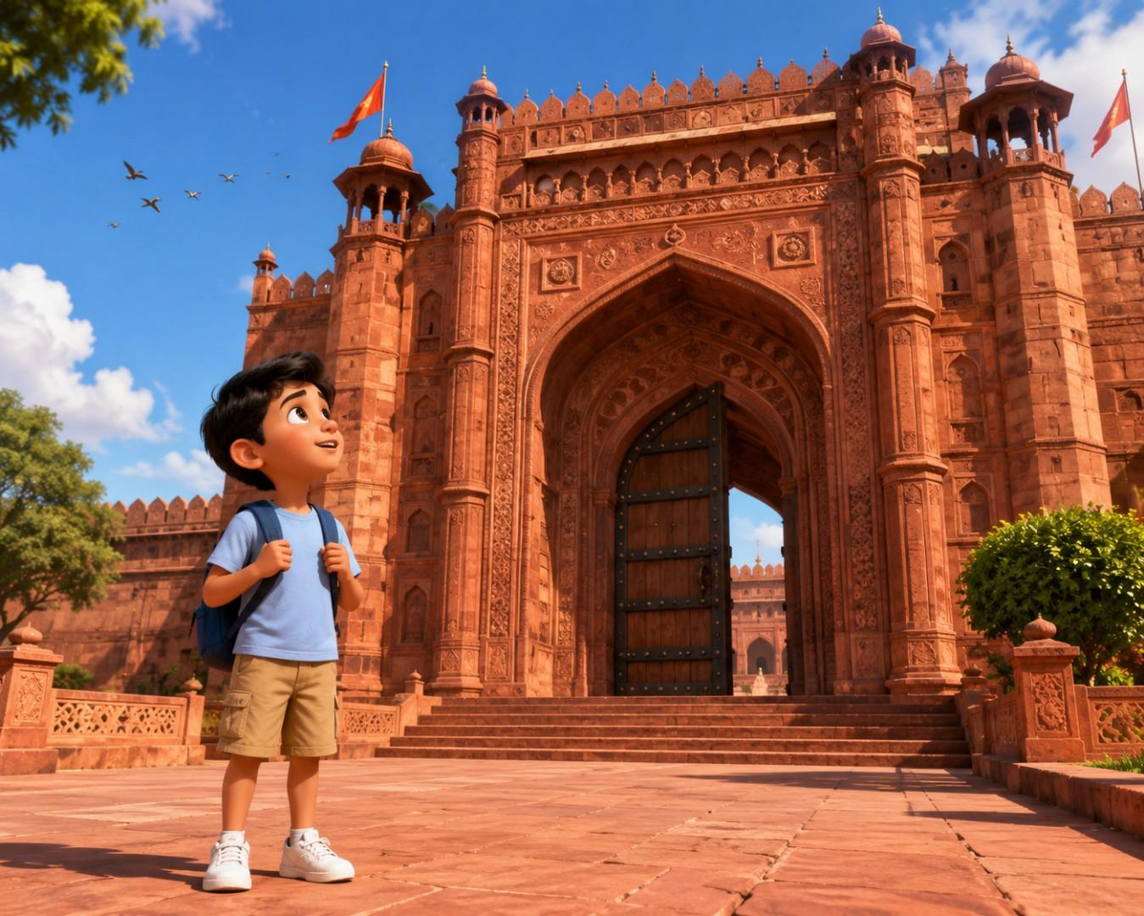

give me scene two

Scene Number
Scene 2

Scene Title
The Royal Guard

Duration
8 seconds

Scene Summary
Aarav has reached the entrance of Fatehpur Sikri. Standing before the enormous royal gate is a disciplined Mughal palace guard holding a ceremonial spear. The guard calmly observes visitors approaching the entrance, creating the feeling that something important happens before anyone is allowed through the gate.

Reference Image Prompt
A magnificent historical scene at the main entrance of Fatehpur Sikri, India. In the foreground stands Aarav, a curious 10-year-old Indian boy with medium-brown skin, a round expressive face, short neatly combed black hair, large dark brown eyes, and a fascinated expression. He wears a light blue short-sleeved T-shirt, khaki knee-length shorts, clean white sneakers, and carries a small navy-blue backpack with both shoulder straps on. He stands slightly to the left of the frame with his body facing the giant gateway while looking attentively toward the palace guard.
At the center stands a 45-year-old Mughal Royal Palace Guard with a calm, authoritative presence. He has medium-brown skin, a neatly groomed black beard and moustache, sharp dark brown eyes, and a composed facial expression. His hair is completely covered by an elegant deep-maroon royal turban decorated with a small golden emblem. He wears a richly detailed Mughal ceremonial uniform consisting of a long crimson robe with intricate gold embroidery, a dark green sash tied around his waist, fitted cream-colored trousers, and traditional brown leather shoes. He carries a tall ceremonial spear made of polished dark wood with a silver spearhead and a small golden tassel below the blade. A polished golden royal insignia hangs from his waist belt.
Behind him stands an enormous double wooden gate made of dark teak wood reinforced with black iron straps and large round rivets, framed by a towering red sandstone Mughal arch richly decorated with floral carvings, geometric patterns, balconies, domes, and carved pillars.
The palace courtyard features broad sandstone paving, trimmed green shrubs, carved stone railings, fluttering royal flags, and distant palace buildings. A few pigeons rest on the upper ledges while birds fly across the bright blue sky.
Late-morning sunlight casts warm golden illumination across the sandstone walls, producing soft realistic shadows. The atmosphere feels majestic, peaceful, and mysterious, inviting curiosity about what lies beyond the gate.
Foreground: textured sandstone pathway leading toward the guard with Aarav standing nearby.
Midground: Royal Guard positioned directly in front of the massive gate holding the ceremonial spear vertically.
Background: towering Fatehpur Sikri gateway, carved Mughal architecture, palace walls, fluttering flags, trees, and clear blue sky with soft white clouds.
Camera angle: eye-level medium-wide cinematic shot emphasizing both Aarav and the guard while keeping the monumental gateway dominant.
Lens: 35mm cinematic lens.
Depth of field: moderate depth of field with Aarav and the Royal Guard perfectly sharp while the distant palace architecture remains slightly softened.
Rendering style: stylized cinematic educational 3D animation with physically based rendering, realistic sandstone textures, soft global illumination, volumetric sunlight, warm heritage-inspired Indian color palette dominated by sandstone red, royal gold, emerald green, sky blue, and rich earth tones.
Pixar-quality 3D animation, ultra detailed, cinematic composition, global illumination, volumetric lighting, expressive faces, child-friendly, vibrant Indian colors, professional lighting, 8K.

Reference Image Negative Prompt
low quality, bad anatomy, extra limbs, extra fingers, cropped, logo, watermark, text, duplicate character, distorted face, wrong costume, wrong lighting, oversaturated, AI artifacts, motion blur

SnapGenAI Video Prompt
The Royal Guard slowly turns his head toward the entrance while maintaining a straight posture and firmly holding the ceremonial spear. His eyes calmly scan approaching visitors with a composed, watchful expression. Aarav remains still, quietly observing the guard with growing curiosity. The camera performs one slow left-to-right cinematic pan, revealing the guard against the towering royal gate. Royal flags flutter gently, tree leaves sway softly in the breeze, and a few birds glide overhead. Character movements remain smooth and realistic with natural cloth movement. Maintain one continuous emotion of calm authority throughout the 8-second shot.

SnapGenAI Negative Prompt
camera shake, face morphing, costume changing, teleportation, extra people, distorted movement, warping, flickering, frame glitches, text, logo, watermark, low quality

Camera Direction
Shot Type: Medium-Wide Character Introduction Shot
Camera Angle: Eye Level
Lens: 35mm Cinematic Lens
Movement: Slow Left-to-Right Pan
Framing: The Royal Guard occupies the center of the frame with Aarav positioned in the left foreground and the monumental gateway filling the background.

Character Animation
The Royal Guard maintains an upright ceremonial stance, slowly turning only his head to observe the entrance while keeping both hands firmly on the spear. Aarav remains still, subtly lifting his eyebrows and watching the guard with curiosity.

Environment Animation
Royal flags ripple gently in the breeze, nearby tree leaves sway softly, pigeons shift slightly on the sandstone ledges, and sunlight remains warm and consistent across the gateway.

Narration
"A wise guard watches everyone before making a decision."

Dialogue
Royal Guard: (softly) "Welcome, young traveler."

Sound Effects
Gentle breeze, distant birds chirping, faint cloth rustling, soft metallic jingle from the guard's belt ornament, ambient palace atmosphere.

Background Music
Warm orchestral score with Indian flute, soft strings, gentle tabla rhythm, and a subtle sustained note to build anticipation.

Educational Graphics
A small animated magnifying glass icon briefly appears beside the guard with the caption:
"Observe carefully..."
The graphic fades smoothly after two seconds without distracting from the scene.

Transition Suggestion
As the guard finishes observing the entrance, a visitor walks toward the gate, leading naturally into the first decision demonstration.

QUALITY CHECK
- ✓ Character description is complete.
- ✓ Environment description is complete.
- ✓ Reference image is sufficient for SnapGenAI.
- ✓ Only one primary action (the guard slowly turning his head to observe).
- ✓ Only one camera movement (slow left-to-right pan).
- ✓ Duration is 8 seconds.

based on that reference prompt you gave for image generation,create a image

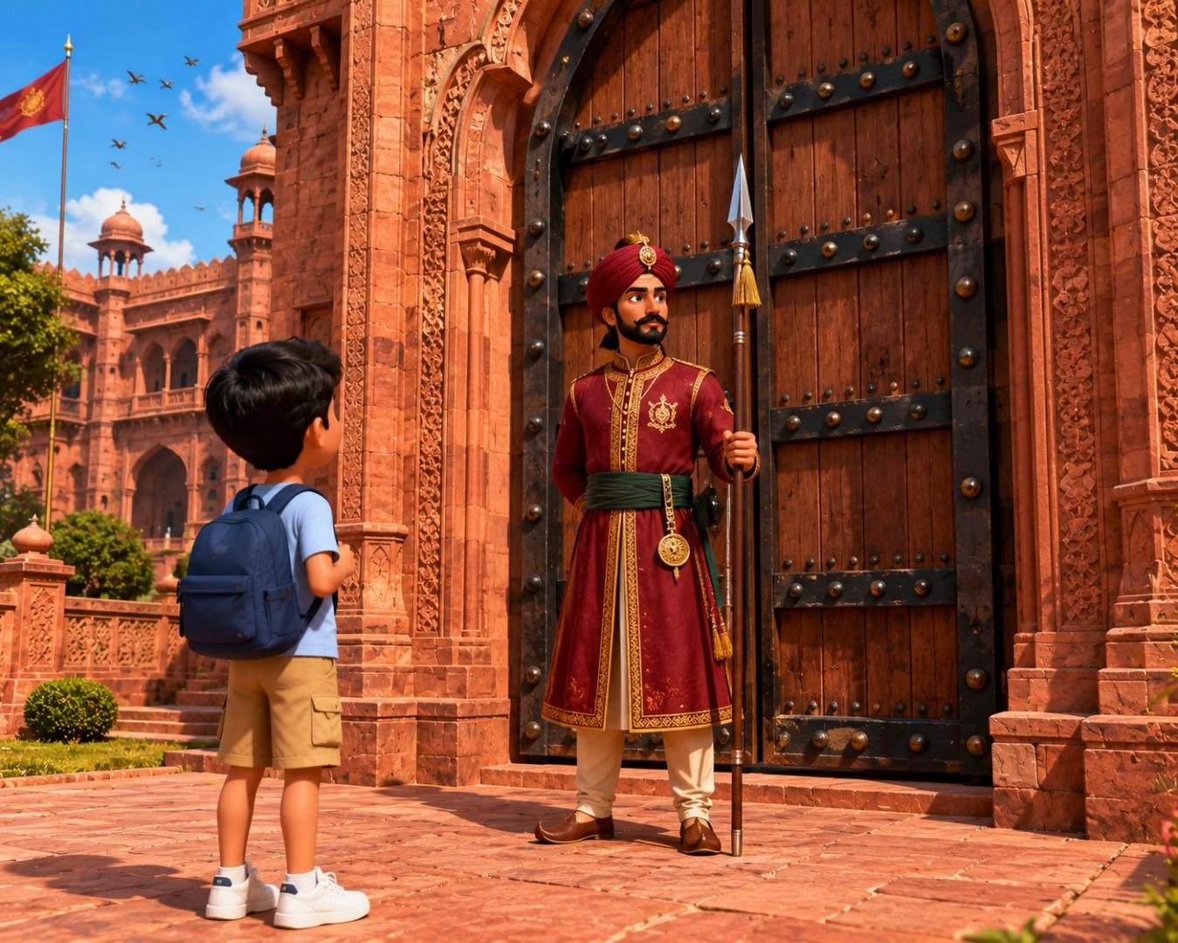

Next Scene

Scene Number
Scene 3

Scene Title
The First Visitor

Duration
8 seconds

Scene Summary
A middle-aged traveler approaches the royal gate at Fatehpur Sikri. The Royal Guard politely raises one hand to stop him and asks a simple question. The traveler confidently answers. The guard nods with approval, and the massive wooden gate begins to open. Aarav watches the entire event carefully, realizing that the guard always checks something before acting.

Reference Image Prompt
A cinematic educational 3D scene at the magnificent main entrance of Fatehpur Sikri, India, during a bright late morning. The environment features authentic Mughal architecture with towering red sandstone walls, intricate floral carvings, decorative arches, carved balconies, sandstone pillars, and an enormous double wooden gate reinforced with black iron straps and large round rivets.
In the left foreground stands Aarav, a curious 10-year-old Indian boy with medium-brown skin, a round expressive face, short neatly combed black hair, large dark brown eyes, and an attentive expression. He wears a light blue short-sleeved T-shirt, khaki knee-length shorts, clean white sneakers, and a small navy-blue backpack worn on both shoulders. His body is slightly turned toward the gate, watching closely with both hands gently holding his backpack straps.
At the center stands the Royal Palace Guard, approximately 45 years old, with medium-brown skin, a neatly groomed black beard and moustache, calm dark brown eyes, and a composed, disciplined expression. He wears a deep maroon Mughal ceremonial turban with a golden emblem, a richly embroidered crimson robe with intricate gold patterns, a dark green waist sash, cream-colored trousers, traditional brown leather shoes, and a polished golden royal insignia hanging from his belt. He firmly holds a ceremonial spear made of polished dark wood with a silver spearhead and golden tassel in his left hand while raising his right hand in a respectful gesture toward the approaching visitor.
Facing the guard is a middle-aged Indian traveler, about 38 years old, with warm brown skin, short black hair, and a neatly trimmed beard. He wears a cream-colored cotton kurta, light brown pajama trousers, simple brown leather sandals, and a mustard-yellow cotton shoulder bag. He smiles politely while standing confidently before the guard.
The enormous wooden gate behind the guard is beginning to open slightly, revealing only a narrow gap into the palace interior, suggesting permission has been granted.
The courtyard contains sandstone paving, trimmed green shrubs, carved stone railings, fluttering royal flags, and a few pigeons perched on the upper ledges. Birds fly across a bright blue sky with soft white clouds.
Warm golden sunlight illuminates the red sandstone architecture, creating soft realistic shadows and a welcoming atmosphere.
Foreground: sandstone pathway with Aarav observing.
Midground: Royal Guard raising one hand toward the traveler while holding the ceremonial spear.
Background: partially opening royal gate, towering Mughal architecture, palace walls, fluttering flags, trees, and blue sky.
Camera angle: eye-level medium-wide cinematic shot emphasizing all three characters while keeping the opening gate visible.
Lens: 35mm cinematic lens.
Depth of field: moderate depth of field keeping all characters and the gate sharp while softly blurring distant structures.
Rendering style: stylized cinematic educational 3D animation with physically based rendering, global illumination, volumetric sunlight, realistic sandstone textures, expressive faces, warm Indian heritage color palette featuring sandstone red, royal gold, emerald green, sky blue, and natural earth tones.
Pixar-quality 3D animation, ultra detailed, cinematic composition, global illumination, volumetric lighting, expressive faces, child-friendly, vibrant Indian colors, professional lighting, 8K.

Reference Image Negative Prompt
low quality, bad anatomy, extra limbs, extra fingers, cropped, logo, watermark, text, duplicate character, distorted face, wrong costume, wrong lighting, oversaturated, AI artifacts, motion blur

SnapGenAI Video Prompt
The Royal Guard slowly raises his right hand toward the traveler in a respectful questioning gesture while maintaining a firm ceremonial stance and holding the spear with his left hand. The traveler stops naturally and smiles confidently without moving further. Aarav remains still, watching with focused curiosity. The camera performs one slow forward dolly toward the interaction. Royal flags ripple gently, birds glide overhead, and tree leaves sway softly. Maintain one continuous emotion of calm curiosity throughout the 8-second shot with realistic cloth and body movement.

SnapGenAI Negative Prompt
camera shake, face morphing, costume changing, teleportation, extra people, distorted movement, warping, flickering, frame glitches, text, logo, watermark, low quality

Camera Direction
Shot Type: Medium-Wide Interaction Shot
Camera Angle: Eye Level
Lens: 35mm Cinematic Lens
Movement: Slow Forward Dolly
Framing: Aarav occupies the left foreground, the Royal Guard remains centered, and the traveler stands on the right, with the slightly opening gate visible behind them.

Character Animation
The Royal Guard raises his right hand in a calm questioning gesture while keeping his spear upright in his left hand. The traveler naturally stops and nods with a confident smile. Aarav watches silently without moving, his eyes fixed on the interaction.

Environment Animation
Royal flags flutter gently, tree leaves sway softly, pigeons shift slightly on the gateway ledges, and the heavy wooden gate begins opening slowly with realistic weight and movement.

Narration
"Before opening the gate, the guard always checks one important thing."

Dialogue
Royal Guard: "May I ask you one question?"
Traveler: "Of course."

Sound Effects
Heavy wooden gate creaking softly, gentle breeze, birds chirping, light footsteps on sandstone, subtle metallic jingle from the guard's belt.

Background Music
Gentle orchestral score with Indian flute, warm strings, soft tabla rhythm, and a subtle rising motif to build anticipation.

Educational Graphics
A small floating icon appears briefly above the guard's raised hand:
❓ Check First
The icon fades smoothly after two seconds without interrupting the story.

Transition Suggestion
As the gate opens for the traveler, cut to another visitor approaching, preparing learners to observe a different outcome.

QUALITY CHECK
- ✓ Character descriptions are complete.
- ✓ Environment description is complete.
- ✓ Reference image contains all information needed for independent AI image generation.
- ✓ Only one primary action (the guard raises his hand to question the traveler).
- ✓ Only one camera movement (slow forward dolly).
- ✓ Scene duration is 8 seconds.

based on that reference prompt you gave for image generation,create a image

